Nitrate Directive
Government decree n. 103/2003 Coll.

Ing. J a n K l í r , CSc.
Research Institute of Crop Production
Praha - Ruzyně

Implementation of the Nitrate Directive (ND) in the CR
- Has been realised in § 33 of the Act n. 254/2001 Coll. (Water Act, in force from the 1st January 2002)
- Implementing regulation for § 33 of the Water Act is
Government decree n. 103/2003 Coll.,
on designation of vulnerable zones and on use and storage of fertilizers and manure, crop rotation and execution of counter – erosion measures in these zones
- Government decree has been published
in the Collection, it is possible to download it on http://www.mvcr.cz/sbirka/2003/sb042-03.pdf
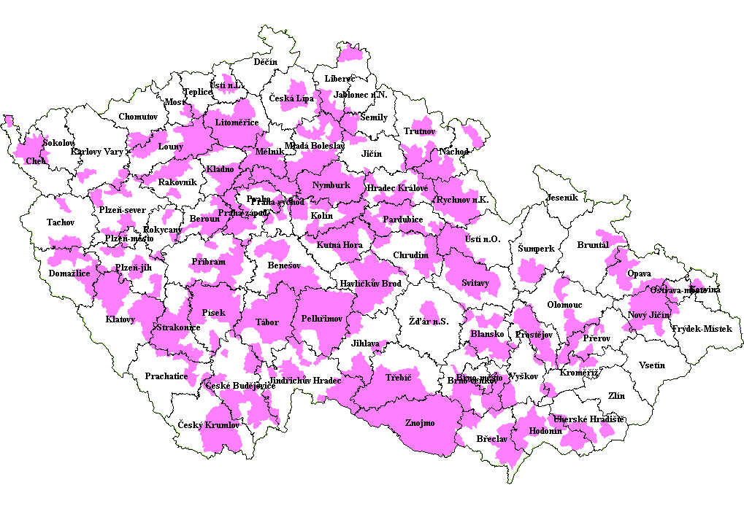
- Virtue of the Government decree:
from 11th April 03
(definition of vulnerable zones)
from 1th January 04
(measures of the „action programme“)

Catchment Areas
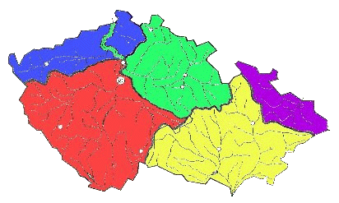

Codes of good agricultural practice for protection of water from nitrate pollution from agricultural sources
- binding for vulnerable areas of the CR
- Recommended on the rest of the territory
- partially required for subsidies and supports

General measures of Codes

· periods of unsuitable application
· ways of fertilising
· agrotechnique
are specified (= made more severe) by the Action programme
considering soil and climatic conditions of the regions
Fertilising of special crops

· vineyards
· hop garden
· orchard

· vegetables, etc.

follow recommended technologies

Government decree
n. 103/2003 Coll.
on designation of vulnerable zones and
on use and storage of fertilizers and manure, crop rotation and
execution of counter – erosion measures
in these zones

Use of fertilizers and livestock manure in vulnerable zones
Definitions of fertilizers and livestock manure for purpose of the government decree:
mineral nitrogen fertilizers, organic and organomineral fertilizers and manure =
nitrogen fertile substances, divided into:
- mineral nitrogen fertilizers = mineral singlenutrition N fertilizers, mineral multinutrition fertilizers containing nitrogen
- fertilizers or manure with N released quickly = manure as slurry, dung-water, poultry manure, poultry litter, and organic and organomineral fertilizers with ratio of C : N < 10
- fertilizers or manure with N released slowly = manure as farmyard manure, organic and organomineral fertilizers with ratio of C : N ³ 10, e.g. well-ripened compost

Use of fertilizers and livestock manure with regard to soil and climatic conditions of the site
• Fertilizers and manures may only be used if their infiltration to surface and ground waters does not menace
(this does not concern fertilizing of lakes).

Limitation of input of organic nitrogen into agricultural land
•Amount of total nitrogen applied annually on agric.land in livestock manure, organic a organomineral fertilizers shall not in average of the farm go over the limit of 170 kg . ha-1,including agricultural land suitable for application.
•The term land suitable for application stands for every used agricultural land of the firm, minus
a) surfaces, where fertilizing is prohibited, e.g. close to surface water bodies, built-up territory of a municipality or protection zones of water resource,
b) leguminous crops (alfalfa etc.)
c) unused surfaces , fallow lands and set-asides.

Storage of fertilizers and livestock manure
•Stables, storage facilities for fertilizers and livestock manure and storaged bulk feed and other facilities have be safe against leakage of any harmful substance.
•Capacity of storage facilities for livestock manure is set by special legal act (decree n. 274/1998 Coll., on storage and mode of use of fertilizers, as amended by following acts) and has to be sufficient for storage of livestock manure during period of prohibition of fertilizing and during period when fertilizing is not possible because of soil and climatic conditions of vulnerable zone and crop.
•Technical safety measures for storage facilities for livestock manure are set by special legal act(decree n. 191/2002 Coll., on technical requirements for builings in agriculture).

Storage of manure on agricultural land
- Bedding of manure directly on agricultural land is possible only in case that neither surface neither ground water could be polluted or their quality endangered .
- Bedding of manure on agricultural land is allowable max.
during nine months. Bedding of manure at the same place can be repeated at the earliest after four years of farming on the land.

Farming in the surroundings of surface waters

- On lands located next to surface waters, riverine forest is kept; where the riverine forest does not exis, it is necessary to keep a protective belt of unploughed soil of min. 1 m width from the riverine line.
- On lands of slope above 7° (fourth figure of the BPEJ code is four and more) it is necessary to keep a protective belt of width min. 25 m from the riverine line, where liquide livestock manure will not be applied.

Decree n. 274/1998 Coll., on storage and mode of use of fertilizers, as amended by decree n.476/2000 Coll. (from November 2002 amened by decree n.473/2002.)
§ 4 „Storage of livestock manure“
- Capacity of storage facilities have to correspond with the real production of farmyard manure or with another solid livestock manure within 6 months. This provision does not apply to livestock manure stored on agricultural land before its use.
- Catchments have to match in capacity minimally expected four-month production of slurry and minimally expected three-months production of liquid manure (dung-water), and this depending on climatic and wheather conditions of the region. During the operation of catchments, influent of surface waters into them have to be excluded.

Decree n. 274/1998 Coll., on storage and mode of use of fertilizers, as amended by decree n.476/2000 Coll.
(an amendment is being prepared, to come into force in January 2004)

Farmers are obliged to record
- the use of assistant soil substances, assistant vegetative products and substrates (further referred to as “assistant substances”), fertilizers, livestock manure and sewage sludges
- crop yields

Records serve to elaborate a final balance estimate of nutritions for the whole agricultural land area managed.

