Basic communication

What is communication?
Without anybody able to give a precise definition, we all know what communication is. As a child we learned to listen and speak, no big deal. Later in school we learned to read and write. These four skills are controlled better and better during a man’s life: we communicate daily, at home, in the street or at the office. A great part of your activities consists of communication. Because we have to make clear what we expect from others and also to get to know what others expect from us. Over the years we also learned how to express best in certain situations.
Without communication e.g. it will be impossible to co-operate with colleagues: we have to discuss things, ask them for information, give them information. Besides that this has to happen in a way that the mutual relationship and the willingness to co-operate stay at a high level. In case of problems, it must be possible to solve these. Communication plays an essential role in this. We must be able to listen and process the information from the other person. We must be able to properly express our own opinion and show willingness to come to a solution. All together we will have to possess a large number of skills.
Many of these skills we learned in daily practice, hardly aware of this learning. Yet it is, because of the great importance of communication, desirable to look at it a bit longer, also from a theoretical perspective.

Communication can be defined as the exchange of information between two parties. The participants in communication we call communicators. All communicators give information and receive information. People can communicate through the spoken and written word, but also by gestures, body language.

Communication is the exchange of information between two communicators

The typical human form of communication is through words (verbal), the spoken language. In practice our words do not always appear to reflect what we meant. Communication is not without bottle-necks. That’s the reason for many misunderstandings. Sometimes this happens unaware: e.g. words may have more than one meaning. But sometimes it happens deliberately: we use words that hide what we feel or think, we cover things up with the language.

Verbal communication is communication with words

But communication exists from more than words, from what is being said. Just think about the situations in which people you were talking to, said something that did not fit with their behaviour. E.g. the man that said: “I am sorry”, while you had the feeling that he was not. He did use the correct wording to show his regret, but the look in his eyes, the smile in his face, the tone of his voice made you think something quite different. There was a clear difference between what he said and how it was said.

Non-verbal communication is communication without words

Somebody who sits completely still, without saying a thing and with his eyes closed, shows a certain behaviour. Most of the times it means that this person does not want to be disturbed; he does not want contact with the people around hem. His (body)language indicates that, sends a message. Without words a message is transmitted. However, also when people communicate verbally, the non-verbal communication plays a role. E.g. the disgust in somebody’s face who talks about spiders or snakes. The height of tone of the voice, the loudness of speaking, the gestures made, even sweating, they all are non-verbal means of expression. They all have message value.
Non-verbal and verbal communication are complementary to each other. There are situations where they contradict. Among other things this happens in the case of sarcasm and irony, or the self-assuredness of reading from a piece of paper while the hands are trembling. Or if somebody asks something in a commanding tone. It is the non-verbal communication that makes us estimate the proper value of this kind of messages.

Verbal and non verbal communication:
- take place at the same time
- can support each other
- can contradict each other

Unilateral communication
Communication is a process where at least two communicators are involved. The communicator who talks, is called the ‘sender’. The things the sender says are called the ‘message’. And the communicator receiving the message is called the ‘receiver’.

In schedule the process can be drawn as follows:

Picture of the sender
Codification of the message
Transport channel
Decodification of the message
Picture of receiver

B
A

Interference Filter from B

In the figure above A is the sender. A has an idea (a picture) in his mind and wants to tell it to B. A will have to explain, to form this picture. That’s called codification. Codification can be done through words or through gestures, verbal or non-verbal means of expression.
When A speaks Chinese and B speaks French, verbal communication is impossible. B will not be able to understand A’s codification and will therefore not decodify the message. Decodification means to transform the code back to a picture. A can also try to make his message clear by gestures (non-verbal communication). In the case that B smiles with appreciation, A can deduce from that, that B understood him. However he will never be sure about this: A cannot check whether the picture in his head is identical to the picture in B’s head.

But also within one single language codification and decodification of the message can give problems, because there are major differences between people. Think about the differences in profession, training level, social status, dialect, etc. These differences make that words (or gestures) do not always have identical meanings. If somebody says that a person is plump, this will probably create a different picture with every other receiver. It may then appear as if people are talking about the same thing, mean the same thing, but the pictures can be completely different.

From this we can conclude the following communication rule:

Do not expect your words to be understood according to your true meaning

The sender will often have to check whether with his message and the way in which it was offered, achieved what he wanted. The communication is successful if the reaction of the receiver is in conformity with the intention of the sender.

Message
Things that two communicators tell each other is called the message. In practice this happens to give ‘quite’ some problems. This has to do with the four functions that can be distinguished in every message. Imagine the following situation:

A couple sits in a car, wife at the wheel, man aside. All of the sudden the man says: ‘The car in front of us slows down’. The man’s message means what it says: the car in front of the couple slows down. We call this the content or reference function of the message.

But this is not all the man says. Between the lines he tells something about himself. E.g. that he pays attention to the traffic, that he is frightened, that he speaks English. The thing the man communicates about himself, is called the (self) expressive function of the message.

At the same time the man says in this sentence how he thinks about the receiver (in this case his wife): do you watch out carefully, aren’t you frightened, I don’t trust your driving skills.
That is called the relational function: the message tells how the sender sees the relation with the receiver and at the same time creates a certain relation.

Finally the man says what he expects from his wife, what he wants her to do with the message: I want you to better take care, I want you to slow down, I want you to put my mind at rest. Communication is not without obligations; every sender wants, expects, that the receiver will do something with the message. That is the appealing function.
These four functions are always present in every message, although of course they will not all have the same importance at every moment. Their interest is determined by the frame of reference and the context.

A message has four functions:

- a content or reference function
- an expressive function
- a relational function
- an appealing function

Codification
Messages have a shape, they are being codified. That codification (the wrapping up of the message) can exist from both verbal and non-verbal signs.
Verbal signs can be communicated orally (spoken language) of in writing (written language). Language is a system of signs and rules to use these signs. Language provides us with grip on reality and creates that same reality. With the help of a language we can abstract, i.e. stand above reality and communicate about abstract items like love, freedom, etc.
But language is not univocal. On the one hand this is because every human being looks at reality in another way and therefore has another frame of reference. On the other hand it often happens that there is not a one-on-one relation between word and thing (between appointee and appointed). One word (e.g. ‘bank’) can mean several things.
Besides verbal signs a codification exists of non-verbal signs. These signs are so numerous that a full listing is impossible, but examples are: being silent, gestures with hands and feet, expression, non linguistic sounds like yawning, intonation, etc.
For communication non-verbal signs are as important as verbal ones, but are even more difficult to interpret unambiguously. If in a college room a student yawns, the teacher can interpret this as ‘The way in which I teach is dull’, or ‘The guy had a nice party last night’.

The codification of the message often is univocal and that may lead to disturbance in communication

Interference
After codification of the message by A it has to be transported to B. For this transport we use a channel. A channel can e.g. have the form of sound waves, like between speaker and listener. It can also be a channel on paper, in hand writing or in pictures (photo’s, drawings). Or an electromagnetic channel, like radio or television.
During this transport all kinds of disturbances can occur. These disturbances are called interference. Interference can be so strong that it is ‘louder’ than the transported signal. Just think about a glass of lemonade spilled on a letter: the message will be hard to read. Or think about a plane crossing very low: the enormous noise makes that the spoken words are not heard. And what to think of serving coffee during a meeting; people loose their interest in what is being said, everybody thinks about the coffee.
In all cases of interference it is better to stop the transport of signals until the interference is over again.
This brings us to the following communication rule:

Stop the communication until the interference is over

Not only interference during the transport can disturb the communication process. Also the sender himself disturbs. In the case that the sender cannot structure his thoughts or does not know his own intentions properly, he will face major difficulty in expressing himself in a logical context. The sender will use lose phrases, contradict himself and send an incoherent and confusing message to the receiver.
Stuttering, talking too loud or too quiet, mumbling; fiercely gesticulating with legs and arms or the opposite: a full stand still; scratching the face or tapping the foot. All disturbances of the sender that can make that the receiver will receive the message bad or wrong. An important communication rule is:

The sender must try not to create blockades that complicate the receipt (the listening to) of the message

In case the sender functions correctly and the interference during the transport is minimal, this will not necessarily mean that the message is received (correctly). Also the receiver can disturb. A receiver not being tuned to the sender is caused by the filter (see figure 1). The functioning of the filter is connected to the receiver’s situation. At the moment that the receiver does not want to listen to the message, because he is busy with other things, the filter starts to function: the receiver hears the sound, but does not transpose that into a meaning. The receiver closes himself off. This also happens if the message arouses pictures to the receiver that he rather wouldn’t see. In case the receiver e.g. feels irritation or feels insulted, a blockade shows up that makes him stop to absorb information. The filter makes that he can close himself off from the message.

The filter functions as a venetian blind. The incoming sunlight can be stopped by it by closing it, or fully stream in by fully opening it. But the sunlight can also be softened with a venetian blind by opening it partly. A filter functions in the same way. When the receiver widely opens his filter, all possible information is received; closing the filter partly means receiving only part of the message. In that case the message gets coloured. This colouring is determined by the frame of reference of the receiver. It is obvious that the stronger the distortion by the filter, the smaller the chance of a successful communication. So:

Try as a receiver to listen as open and unprejudiced as possible

Frame of reference and context
As mentioned before the frame of reference is one of the reasons for interference. Every human being possesses his own unique frame of reference, formed by (personal) values, norms and convictions that are based on his education, training, social contacts, individual talents, interests, experiences, etc. This frame of reference is developing continuously, since people ‘learn’ every day. Not only every individual has a frame of reference, also groups (associations of professionals, political parties) and even whole cultures have their own frame of reference. The frame of reference determines to a high extent the way in which communication takes place. At the level of codification for instance: people can talk about ‘plant protection’ (the farmer), about ‘fighting diseases’ (the biologist) or about ‘spraying poison’ (the environmentalist).
Except for the frame of reference also the context in which the communication takes place, plays an important role. Context means the influence from the outside world on the communication situation. In the example above the context can be further specified as the social context: in a society where thoughts and values differ, these differences can be found back in the communication. Was the intention of the use of the pesticide to get a subsidy from the Ministry of Agriculture, then we have a situational context: the farmer, the biologist, the environmentalist, they all give their opinion from their situation. Would the text be printed in a history book, then we would have a historical context.

Frame of reference and context determine to a high extent the meaning that the receiver gives to a message

Effective communication
For an effective (and successful) communication it is necessary that the frames of reference of A and B have something in common. B’s filter must not block the message completely.

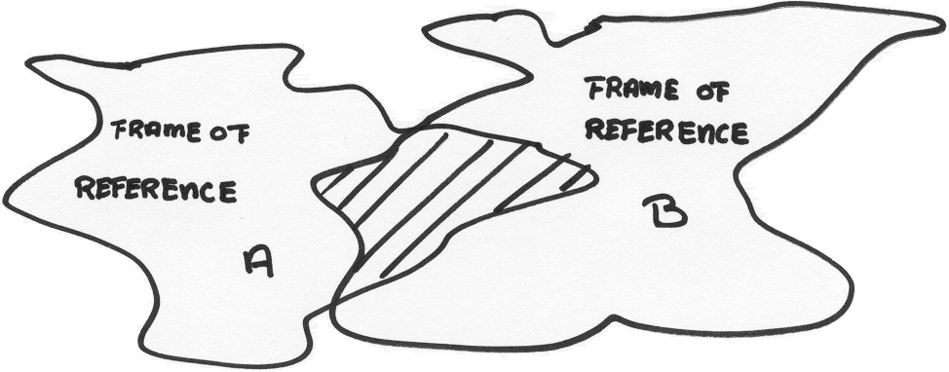
Communication is possible, because the frames of reference of A and B partially overlap. They have something in common (the shaded part). The chance of misunderstandings however is present and even is rather big, since the overlapping area is relatively small.

Every basis for communication is absent if the two world views of A and B differ completely, like in the figure below.

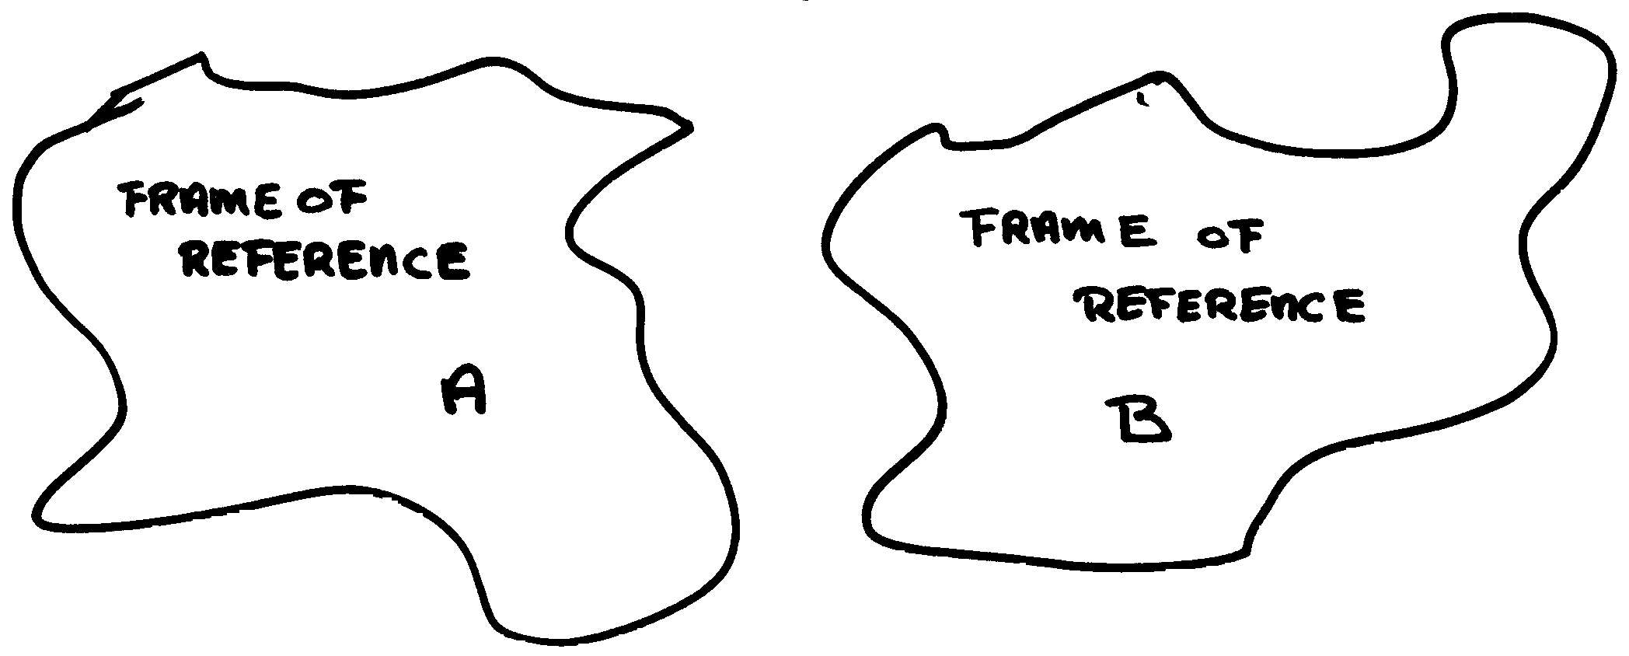
Here the frames of reference of A and B do not have anything in common at all. There can be several reasons for that. There may be ‘hard’ ideological contradictories or completely different ideas about morality. But also the knowledge on the subject that A wants to discuss, can be fully absent for B. There can hardly be communication at all.
The opposite can happen as well of course.

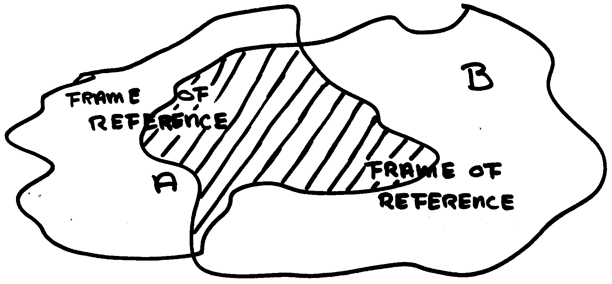
This is the ideal communication situation. The parallels in the frames of reference of A and B is so big that they can sense and experience each others intentions concerning the subject they discuss.
This situation may be present from the very beginning, but can also be the result of communication between A and B. In that situation there has been an effective (and successful) communication.

If you want to communicate effectively, the sender must clearly codify his pictures, the transport must take place without hindrance and the receiver must listen actively. The receiver must try to switch off his filters to the maximum. This leads us to the communication rule:

Try to imagine somebody else’s world

Multilateral communication
So far the communication process was approached as one way traffic: unilaterally from A to B. When A sent out a message and this arrives at the receiver B, then B will process this message. In this B is influenced by the filter. The processing by B may look as follows:

“I do not agree with A at all”
“How can A tell that?”
“A is right”
“Do I actually understand A? I will ask him again what he exactly means”

The range of reactions in B is called the internal communication or the inner dialogue. B can now take the role of sender and turn to A, who now becomes the receiver.

Sender

Codification
Transport channel

Decodification

Receiver

Inner dialogue
of B

Inner dialogue
of A
Filter from A Interference Filter from B

Receiver

Decodifi-
cation

Transport
channel
Codifica-tion

Sender

If B is a good receiver, but still doesn’t get the message through clear enough, he will ask A to clarify things. However if B is a shy person, or afraid to look dumb and therefore he doesn’t ask anything, then the chance of an effective communication is smaller. In case B is completely silent, then A may get the idea that ‘he who is silent, agrees’.
The chance of a successful communication increases when A and B try to find out whether the picture they are transmitting, corresponds with the picture it creates to the other person. Only then proper mutual reactions are possible. An important rule of communication is:

Check whether the intended pictures were received.
Check whether the pictures of sender and receiver correspond.

Interaction
A clear codification of pictures is important. Otherwise the communication will fail. Codification exists from a verbal part (saying things in words) and a non-verbal part (body language). These parts can not be separated from each other. They influence each other and therefore the receiver of the codified picture.
When you kick a stone, you influence the stone: it will e.g. roll. The rolling speed of the stone and the direction in which you kicked it, depend on your kick. The stone cannot influence that.
When you play football and you kick your opponent, then you also influence the behaviour of the object. But there is a difference: the behaviour of this object (your opponent) cannot be predicted, contrary to the stone. The opponent may think you kicked him unintended and not react and play on. But he can also think the opposite. He can think you did it on purpose: in that case he may kick you back or pretend he is heavily injured and fall to the ground. The reaction of your opponent on its turn will influence you: in case he kicks back, you may tell him that your kick was an accident. You may also start hitting him in the face.

In this example on football we see an interaction, the mutual reaction and the mutual influence.

Interaction is mutually influencing each other

Five fundamental rules can be distinguished during interaction.

People continuously influence other people

As soon as a person is in a situation where others are involved, he influences and is being influenced. He cannot escape from this influence of communication.
Human beings have three way of dealing with communication. First of all they can accept the communication. For instance: two people meet in the street; they stop, shake hands and start talking.
But communication can also be rejected. For instance: the same two people meet again the next day and stop. One of them wants to start the conversation, but the other one makes his apology and walks on.
Third possibility is that the communication is neglected. Then there is no agreement what so ever between the communicators. For instance: a week later they meet again during a cocktail party. One of them stops intending to have a talk, but the other one walks on without looking at him. Communicators influence each other continuously (especially if they want to withdraw from communication!!) and behave accordingly. This influence results in the behaviour of people.

People mutually influence each other with, but especially without words

Some cultures are strongly fixed and trained in paying attention to things people say. Yet things that people say hardly ever have a direct interest for the other person. A lot of influence comes from the non-verbal language. These are things like the height of the voice, the volume, the rhythm; but also the mimic, the pose, the distance. So all the signals that are transmitted together with the words. The big influence of non-verbal language becomes e.g. clear when people are in love or in case they have a strong fight: the things said, the (meaning of the) words, is subordinate to the way in which this is being done.

What I think is true, is not necessarily true for the other person

Which impressions are and which are not processed, differ from brain to brain. It very much depends on what (at certain moments) is relevant to a person. And what is relevant to a person, seems to be determined by criteria outside the individual consciousness and by the frame of reference. Since every consciousness is different and picks up its own relevant issues, the way in which people ‘look at the world’ differs from person to person. Finally it means that the truth is a relative concept: one person’s truth is not necessarily the other person’s truth.
Communication problems often occur, because people suppose they have the same view on reality as the other person.

When I say something, I also say how the other person has to handle it

The contents of the message reflects what I say (level of contents). At the same time I also say something about my thoughts about the other person and what I expect from him. The environment in which I say something (level of context), strongly influences what I say. Think e.g. of giving a reprimand to a person in public. The presence of the audience strengthens the feeling of shame. People mainly tend to communicate at the level of contents. Problems at the level of the context or relation are often transferred to the level of contents. Of course this will not be successful or only with an utmost effort.

Who is the one in charge?
Who will allow the other to be in charge?

People tend to define their relation with other people in a one-sided way: the other person is always shy, authoritarian, etc.
But nobody can determine a relation on his own; a relation never depends on one person, you need at least two. If somebody behaves authoritarian, this is only possible because the other person allows him to and sees himself as obedient or modest. At every moment in a relationship people are obliged to determine their attitude towards the other person. One can have a leading role, prefer a following attitude or behave as an equal party.

Feedback
Although not always clearly visible, the receiver always reacts. The sender must continuously watch the reaction of the receiver. The reaction(s) of the receiver to the message of the sender is called feedback, a form of interaction. Feedback can both be verbal or non-verbal and concerns the way in which the message was received and interpreted.

Two people sit in the train and A asks B, who is closest to the window:
“Would you please close the window?” B now can react in different ways.

- He can stand up, close the window and say: “Well, that’s more comfortable”.
In this case the message was received and carried out, perhaps because B also felt cold.

- B however can also look at A in a questioning way. To A this makes clear that B did not hear his question; the message did not arrive.

- But B can also continue to look out of the window. A can consider this feedback as “Leave me alone”. B will probably not carry out the message. In this case A can ask B for a reaction (direct feedback): “Didn’t you hear my question?” or “Would you prefer to keep the window opened?”
B can react on this or, without saying anything, leave the compartment. In the last situation we speak about indirect feedback.

The purpose of feedback is to clarify the communication situation between two communicators. Through feedback the situation can be stabilised, like in the first example where B closes the window. But the communication situation can also change by the feedback, like in the third example where B stubbornly continues to stare out of the window. The communication situations changes: B doesn’t want to have to do anything with A, although A wanted so with B.
Except for continuation or change feedback be focussed on expectations for the future, the so called anticipating feedback (also called ‘feed-forward’). In daily life we give a lot of this kind of feedback, e.g. when we are walking in the street and continuously speed up and slow down to avoid to run into other pedestrians. Mister A shows an anticipating feedback by closing the window before the train starts riding, because from former experience he knows he will get cold.

Feedback can be focussed on:
- stabilisation of the situation
- change of the situation
- expectations for the future

