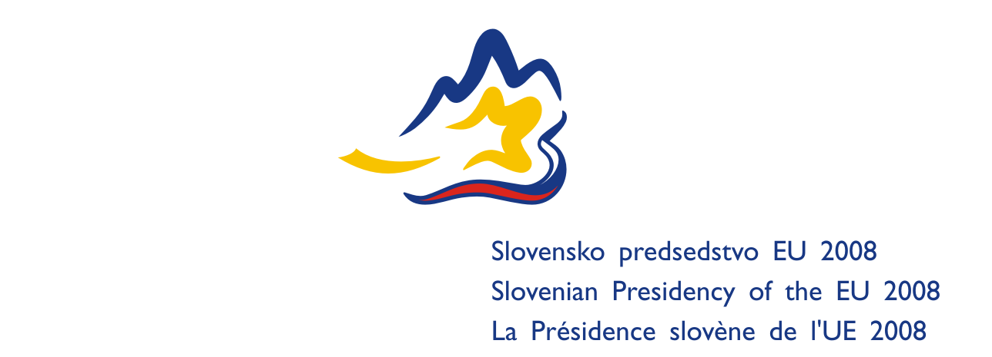
REGISTRATION FORM  Please return the completed form by 18th April 2008 at the latest by e-mail or fax to:  Ministry of the Environment and Spatial Planning  Dunajska cesta 48, SI-1001 Ljubljana, Slovenia  Contact person: Urška Škraba  Fax: +386 1 478 7386  Telephone: +386 1 478 7376  E-mail address: urska.skraba@gov.si | 31st IMPEL Plenary Meeting &  1st IMPEL General Assembly  Brdo, Slovenia  28–30 May 2008
(please use CAPITAL LETTERS)
TITLE:  SURNAME: |  |  |  |  |  |  |  |  | FIRST NAME:
GENDER: M F
PHONE: |  |  |  |  | E-MAIL:
COUNTRY (DELEGATION NAME):
INSTITUTION:

OFFICIAL ADDRESS:
(Street, number, city, country)

OFFICIAL POSITION:
Particular requirements:
( type of room, mobility, sight, hearing, dietary etc.)

ARRIVAL DATA
DATE: |  |  | TIME: |  |  | PLACE  OF ARRIVAL:
TRANSPORT TYPE:
PLANE |  | FLIGHT NUMBER: |  |  |  |  | FROM:
TRAIN |  | TRAIN NUMBER: |  |  |  |  | FROM:
CAR
brand: model: license plate no.:
border crossing
date: time: name of border crossing:
driver
surname: name: phone:
DEPARTURE DATA
DATE: |  |  |  | TIME:
TRANSPORT TYPE:
PLANE | FLIGHT NUMBER: |  |  |  |  |  |  | DEPARTURE  AIRPORT:
TRAIN | TRAIN NUMBER: |  |  |  |  |  |  | DEPARTURE  STATION:
CAR | NAME OF BORDER CROSSING:
OUTBOUND DESTINATION:

ADDITIONAL INFORMATION FORM

ACCOMODATION:

The Presidency has booked rooms for participants at the Grand Hotel Union and Garni Hotel for two nights, i.e. from 28th to 30th May 2008.

Grand Hotel Union  Miklošičeva 1  SI-1000 Ljubljana  Telephone: +386 1 308 1270  Fax: +386 1 308 1914  E-mail: hotel.union@gh-union.si  Website: www.gh-union.si | Garni Hotel  Miklošičeva 9  SI-1000 Ljubljana  Telephone: +386 1 308 4300  Fax: +386 1 230 1181  E-mail: hotel.garni@gh-union.si  Website: www.astralhotel.net
single room: € 199,01  Prices include tourist tax, breakfast and VAT | single room: € 150,01  Prices include tourist tax, breakfast and VAT

Please indicate if you have been nominated by your IMPEL Co-ordinator for payment of accommodation by host in the Grand Hotel Union

YES NO

Participants who decide to make their own hotel booking are kindly requested to send the information about their hotel arrangements to Ms Urška Škraba (urska.skraba@gov.si).

In case you wish to change or cancel your reservation, please notify Ms Urška Škraba prior to your arrival, not later than 21 May 2008.

ACCOMPANYING PARTNER YES NO

SURNAME: FIRST NAME:

Date of Arrival: Date of Departure:
SOCIAL EVENTS:

Accompanying person
Wednesday 28th of May 2008
I would like to take part in the dinner. Yes No Yes

Thursday 29th of May 2008
I would like to take part in the dinner. Yes No Yes

Friday 30th of May 2008
I would like to take part in the trip to Cerkniško jezero. Yes No Yes

