Benchmark no. 5.3

Project website, updated and maintained

Benchmark prepared by:

Pavel Sřemer (CZ) – OZV CEI Directorship, Prague, BC Project Leader
Rob Bakx (NL) – InfoMil, RTA

Date: 3 June 2005

Project website, updated and maintained

In the second week of the project the creation of a project website was discussed with the head of the IT department of the Czech Environmental Inspectorate (ČIŽP). It was agreed to make the project website part of the ČIŽP website under the heading “International affairs”. It would contain both an English and a Czech version with identical (but language specific) content.

In the second month of the project the home page was developed and made available for website visitors. The information on the site is public information. ČIŽP and project staff was involved and trained to maintain the site on a regular basis. Since that moment on the website has been constantly maintained and not only once a month. Each time that new information (presentations, documents, reports, etc.) was ready and available, it was put on the site. The ČIŽP even hired external work force to support the maintenance activities.
During the project workshops and other contacts between internal and external people, the project staff permanently referred to the website as an information source about the project progress, agendas and results.

At the date of drafting of this benchmark document the project website contains …. GB of data. Annex 1 shows the home page of the site, including the latest date of updating and an example of a page. Annex 2 contains an overview of the way in which the site is built up (the ‘site map’).
The website address is: www.cizp.cz

The information that can be found on the site includes:

- Home page
- Links with sites of other Phare projects
- Links to the sites of organisations in the inspection and enforcement network
- Project covenant
- Project planning of activities
- Invitation letters and agendas of project activities
- Workshop presentations
- Background documents
- Evaluation results of workshops
- Results of discussions/brainstorms during round tours
- Developed strategic plan
- Prepared investment plan
- Project newsletters

Updating has been taking place continuously with involvement of :

- 3 staff members of the International Affairs Department of the CIZP
- all 3 staff members of the twinning project (RTA, PA and PLA)
- 3 staff members of the IT Department of the CIZP (Head, Deputy Head and expert).

ANNEX 1

Home Page and last update
HOME PAGE CZECH ENVIRONMENTAL INSPECTORATE (ČIŽP)
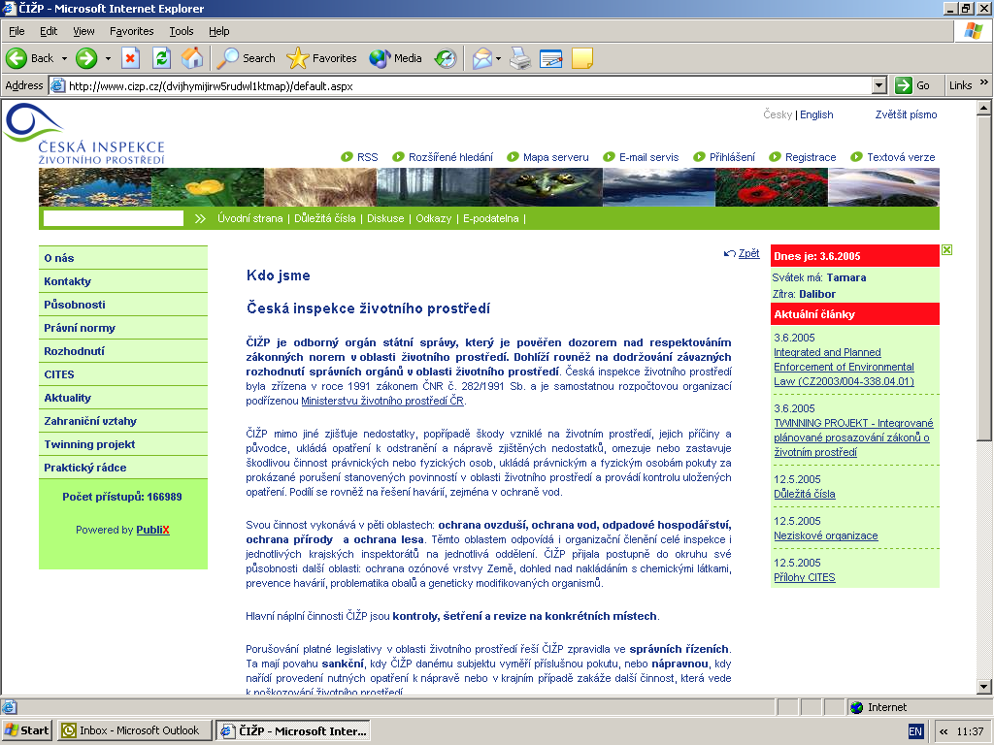

HOME PAGE PROJECT SITE (English version)

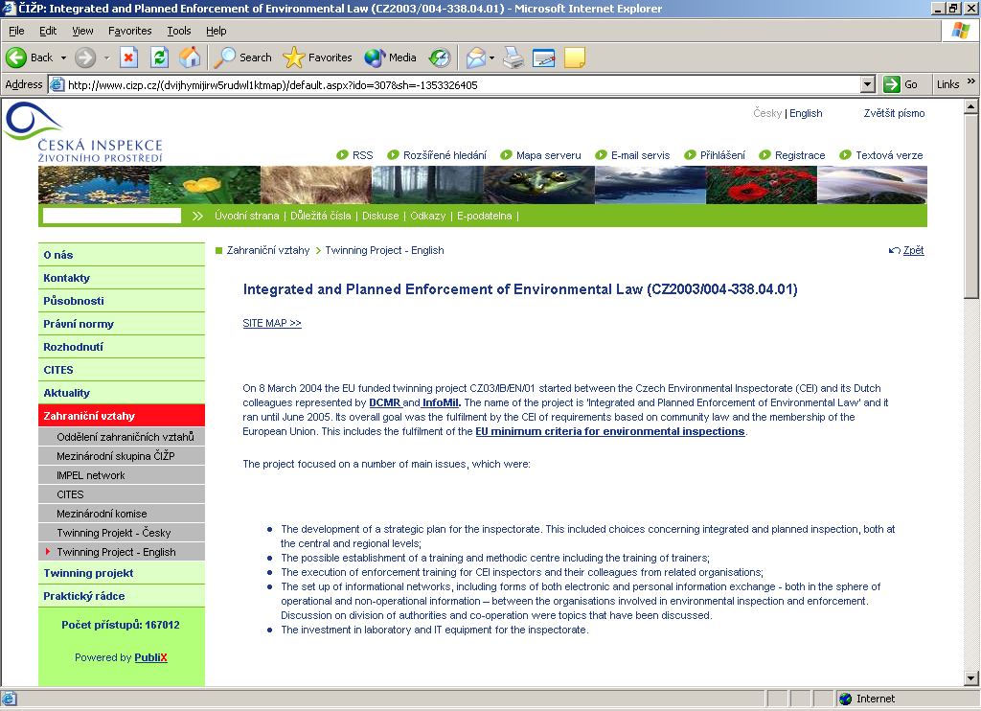

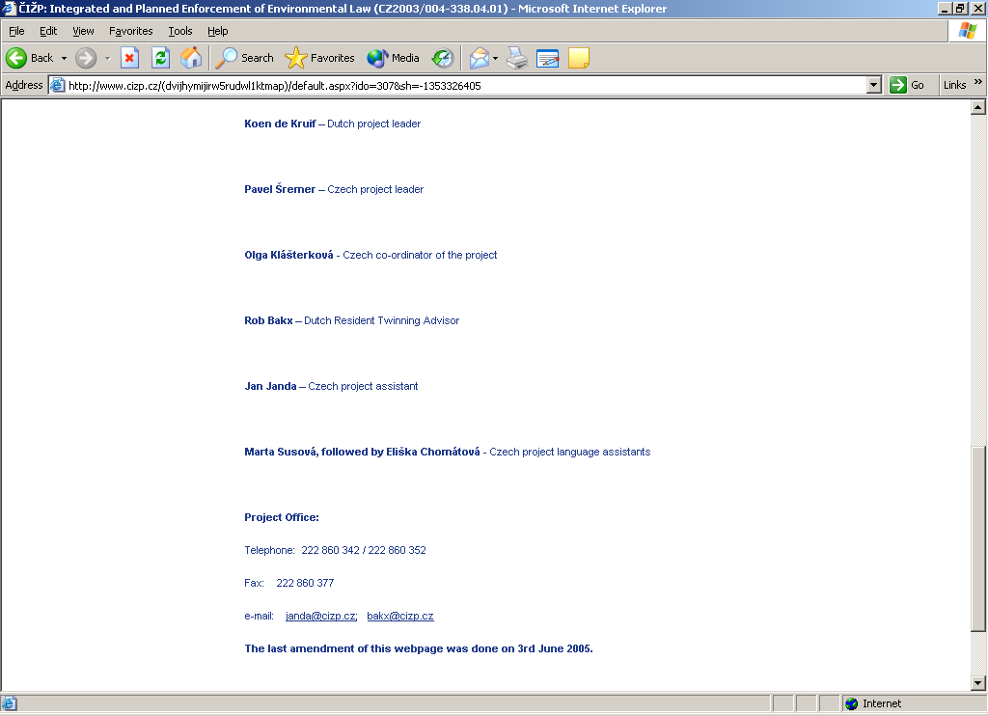
HOME PAGE PROJECT WEBSITE – UPDATE DATE

PROJECT WEB SITE – EXAMPLE OF PAGE

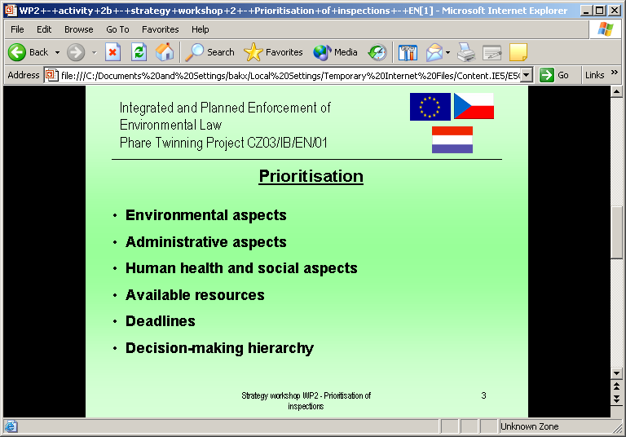

ANNEX 2

Site Map
SITE MAP OF PROJECT WEB SITE

Phare Project: “Integrated and Planned Enforcement of Environmental Law”
- DCMR
- InfoMil
- EU minimum criteria
- Covenant
- Work Packages (including background materials)
Inception phase
- benchmarks and activities in Work package 1
- project objectives

Strategic plan development: Integrated inspection approach
- benchmarks and activities in Work package 2
- background documents
- evaluation of the strategic planning workshops (9.6.-27.8.2004)
- IMPEL handbook for management of environmental inspectorates
- results of the participatory workshops (14.6.- 29.6.2004)

Training program
- benchmarks and activities in Work package 3
- background documents
- workshops (21.9.-24.9.2004) , (26.10.2004), (10.-12.11.2004), (18.-19.11.2004)
- seminars combined with inspector’s training (24.-28.1.2005), (7.-10.3.2005)

Informational networks
- benchmarks and activities in Work package 4
- background documents
- first, second and third workshop
- workshop at management

Project Management
- benchmarks and activities in Work package 5
- project steering committee
- newsletters, quarterly reports

- Benchmarks – finalised ones
- Work packages 1-5 (benchmarks)
- Project Planning
- The most relevant projects co-ordinated with this project
- The Phare 2002 twinning project on Reinforcement of IPPC Implementation
- The Phare 2003 project on Environmental Information and Management System

- Newsletters
- Steering Committees
- Project partners

