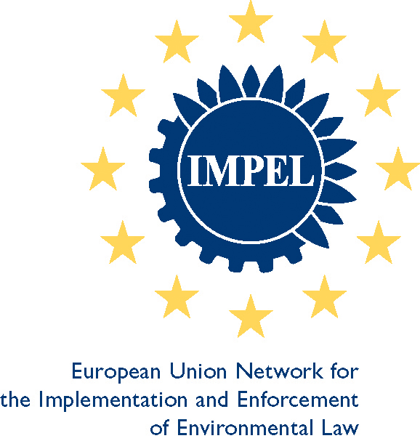

REGISTRATION FORM  Please return the completed form by 30th April 2010 at the latest by e-mail or fax to:  CZECH ENVIRONMENTAL INSPECTORATE  Na Břehu 267  Prague 9 – Vysočany, 190 00, Czech Republic  Contact person: Simona Dobisová  Fax: +420 283 892 662  Telephone: +420 222 860 297  E-mail address: dobisova@cizp.cz | Workshop IMPEL PIAQ,  Comparison Programme Implementation Air Quality standards and industrial air emissions  Prague 14-15 June 2010
(please use CAPITAL LETTERS)
TITLE:  SURNAME: |  |  |  |  |  |  |  |  | FIRST NAME:
GENDER: M F
PHONE: |  |  |  |  | E-MAIL:
COUNTRY (DELEGATION NAME):
INSTITUTION:

OFFICIAL ADDRESS:
(Street, number, city, country)

OFFICIAL POSITION:
Particular requirements:
( type of room, mobility, sight, hearing, dietary etc.)

ARRIVAL DATA
DATE: |  |  | TIME: |  |  | PLACE  OF ARRIVAL:
TRANSPORT TYPE:
PLANE |  | FLIGHT NUMBER: |  |  |  |  | FROM:
TRAIN |  | TRAIN NUMBER: |  |  |  |  | FROM:
CAR
brand: model: license plate no.:
border crossing
date: time: name of border crossing:
driver
surname: name: phone:
DEPARTURE DATA
DATE: |  |  |  | TIME:
TRANSPORT TYPE:
PLANE | FLIGHT NUMBER: |  |  |  |  |  |  | DEPARTURE  AIRPORT:
TRAIN | TRAIN NUMBER: |  |  |  |  |  |  | DEPARTURE  STATION:
CAR | NAME OF BORDER CROSSING:
OUTBOUND DESTINATION:

ADDITIONAL INFORMATION FORM

ACCOMODATION:

All participants will be accommodated in hotel Clarion Congress Hotel Prague. We booked rooms for two nights, i.e. from 13th to 15th June 2010. If You would like to stay longer or If You would like to have Twin superior room, please send information to Ms Simona Dobisová ( dobisova@cizp.cz ).

Clarion Congress Hotel Prague ****
Freyova 33
CZ 190 00 Prague 9 – Vysočany
Web Site: www.cchp.cz

Participants who decide to make their own hotel booking are kindly requested to send the information about their hotel arrangements to Ms Simona Dobisová
( dobisova@cizp.cz ).

In case you wish to change or cancel your reservation, please notify Ms Simona Dobisova prior to your arrival, not later than 22. May 2010.

SOCIAL EVENTS:

Monday 14th of June 2008
I would like to take part in the dinner. Yes No

